Rymbayeva Anelya, 2 course, Lab2 – IT Infrastructure and Computer Networks

1. Click the **Simulation** mode icon to switch from **Realtime** mode to **Simulation** mode.

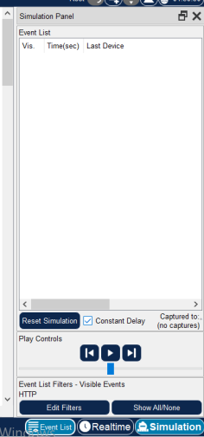

1. Select **HTTP** from the **Event List Filters.**

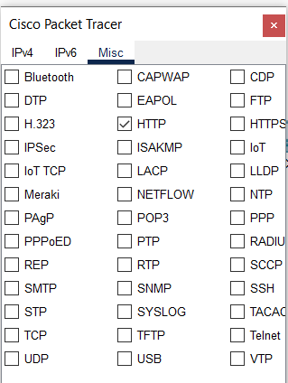

1. Click **Web Client** in the far left pane.

Click the **Desktop** tab and click the **Web Browser** icon to open it.

In the URL field, enter [**www.osi.local**](http://www.osi.local)and click **Go.**

Click **Capture/Forward** four times. There should be four events in the Event List.

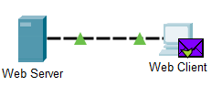

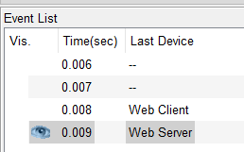

1. Look at the Web Client web browser page. Did anything change?

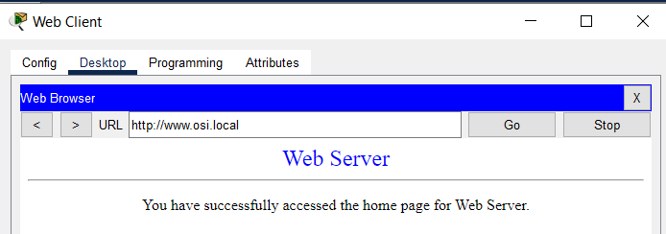

1. Click the first colored square box under the **Event List -> Type** column. It may necessary to expand the **Simulation Panel** or use the scrollbar directly below the **Event List**.

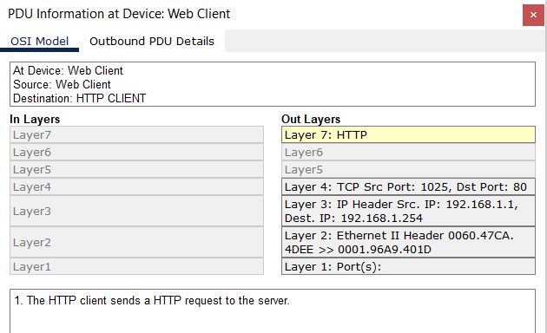

1. Ensure that the **OSI Model** tab is selected.

Under the **Out Layers** column, click **Layer 7.**

What information is listed in the numbered steps directly below the **In Layers** and **Out Layers** boxes for Layer 7?

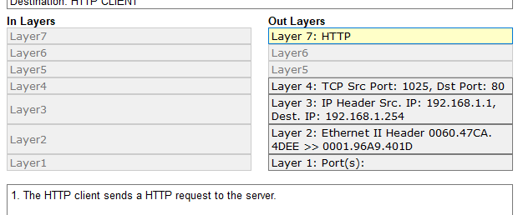

1. What is the **Dst Port** value for **Layer 4** under the **Out Layers** column?



1. What is the **Dest. IP** value for **Layer 3** under the **Out Layers** column?



1. What information is displayed at Layer 2 under the **Out Layers** column?



1. Click the **Outbound PDU Details** tab.

What is the common information listed under the **IP** section of **PDU Details** as compared to the information listed under **OSI Model** tab? With which layer is it associated?

*SRC IP and DST IP at Layer 3*

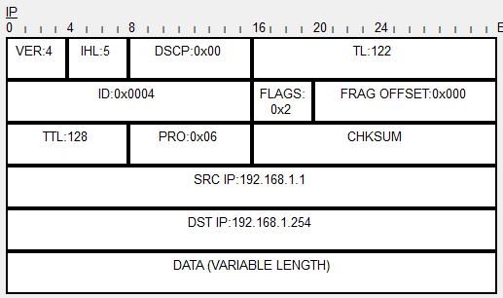

1. What is the common information listed under the TCP section of PDU Details, as compared to the information listed under the OSI Model tab, and with which layer is it associated? *SRC PORT and DEST PORT at Layer 4*
2. What is the Host listed under the HTTP section of the PDU Details? What layer would this information be associated with under the OSI Model tab? *www.osi.local , Layer 7*
3. Click the next colored square box under the **Event List -> Type** column. Only Layer 1 is active (not grayed out). The device is moving the frame from the buffer and placing it on to the network.

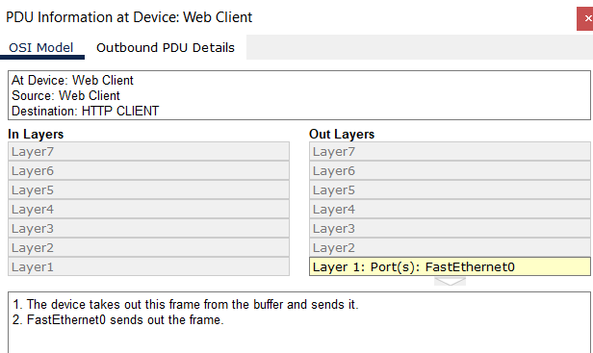

1. Comparing the information displayed in the **In Layers** column with that of the **Out Layers** column, what are the major differences? The Src and Dst Ports, Src and Dst IPs and MAC addresses have been swapped.
2. Click the **Inbound and Outbound PDU Details** tabs. Review the PDU details.

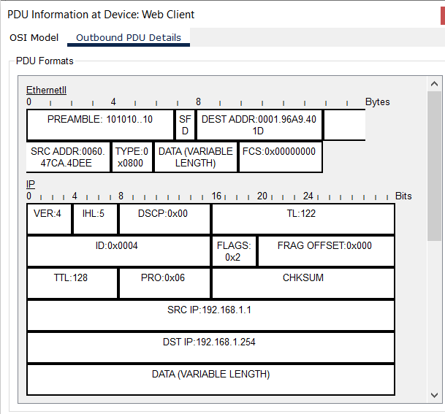

1. Click the last colored square box under the **Info** column.

How many tabs are displayed with this event? Explain: just 2, one for the OSI Model and one for Inbound PDU Details because this is the receiving device.

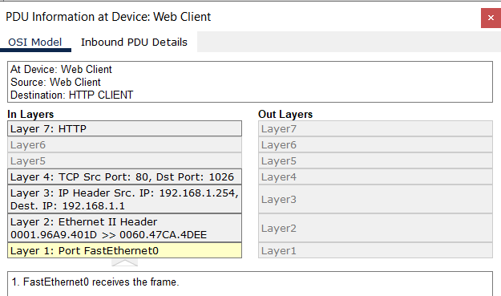

1. Close any open PDU information windows. In the Event Filters > Visible Events section, click Show All/None. What additional Event Types are displayed?

*Depending on whether any communication has occurred prior to starting the original simulation, there should now be entries for ARP, DNS, TCP and HTTP. It is possible that the Arp entries may not show, depending on what a student may have done prior to going to simulation mode. If the activity is started from scratch all of those will be listed.*

1. Click the first DNS event in the **Type** column. Explore the **OSI Model** and **PDU Detail** tabs and note the encapsulation process. As you look at the **OSI Model** tab with **Layer 7** highlighted, a description of what is occurring is listed directly below the **In Layers** and **Out Layers.**

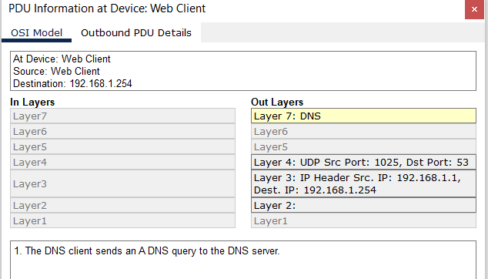

1. Click the **Outbound PDU Details** tab.

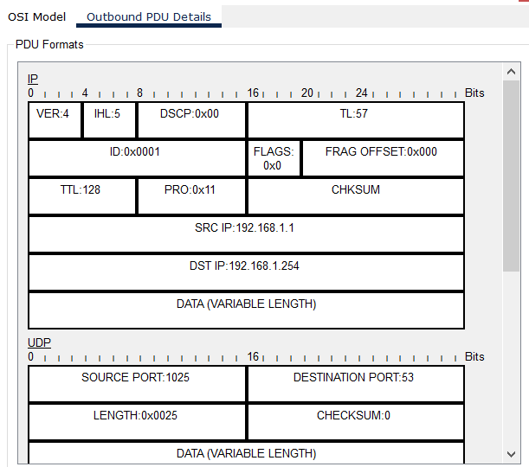

1. What information is listed in the **MANE** field in the DNS QUERY section?

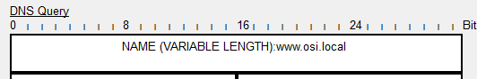

1. Click the last DNS **Info** colored square box in the event list.

At which device was the PDU captured? What is the value listed next to **ADDRESS** in the DNS ANSWER section of the **Inbound PDU Details?**

*At device Web Client*

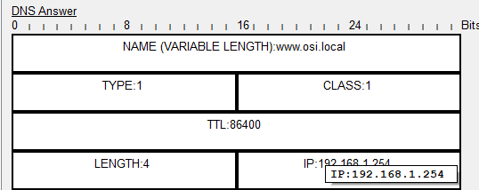

1. Find the first **HTTP** event in the list and click the colored square box of the **TCP** event immediately following this event. Highlight **Layer 4** in the **OSI Model** tab.

In the numbered list directly below the **In Layers** and **Out Layers,** what is the information displayed under items 4 and 5?

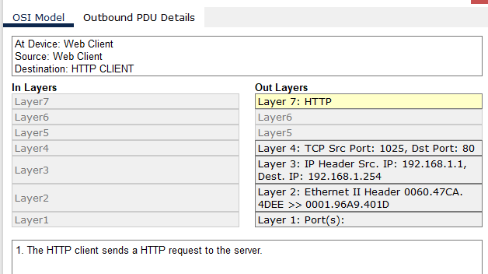

1. Click the last TCP event. Highlight Layer 4 in the **OSI Model** tab. Examine the steps listed directly below **In Layers** and **Out Layers.** What is the purpose of this event, based on the information provided in the last item in the list (should be item 4)?

*Connection close.*

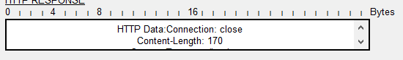

1. Based on the information that was inspected during the Packet Tracer capture, what port number is the **Web Server** listening on for the web request?

*The first HTTP PDU being requested by the Web Client shows port 80 under the Layer 4 DST port.*

1. What port is the Web Server listening on far a DNS request?

*The first DNS PDU being requested by the Web Client shows a Layer 4 destination of a port 53.*